Product Requirement Document

Table of Contents

**Goal** **2**

**User Personas** **3**

**User Stories** **9**

**Server Site Map** **10**

**Page Description** **11**

**Wireframe** **12**

**Interfaces** **13**

**Additional Functional Requirements** **14**

**Non-functional Requirements** **15**

**Performance Requirements** **16**

**Future Iterations** **17**

# 

# Goal

Cooking is essential in everyday life and there’s nothing more frustrating than having to go through multiple Google searches as well as a ton of filler text before the actual recipe. Even while cooking, it’s easy to forget about the process when things come up. Our product aims to solve the problem of useless text filling up the screen and only focusing on what’s important as well as a method to keep users notified. The product allows users to quickly search for recipes with only a simple keyword as well as a simple and interactive UI for easier navigation throughout the cooking experience.

# User Personas

Student:

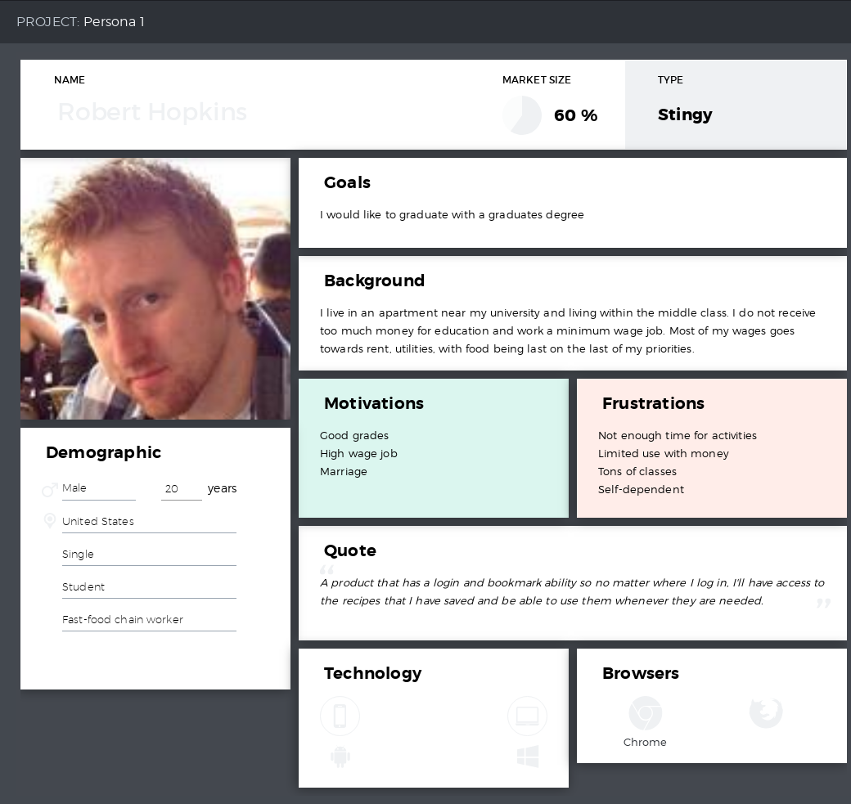

Households:

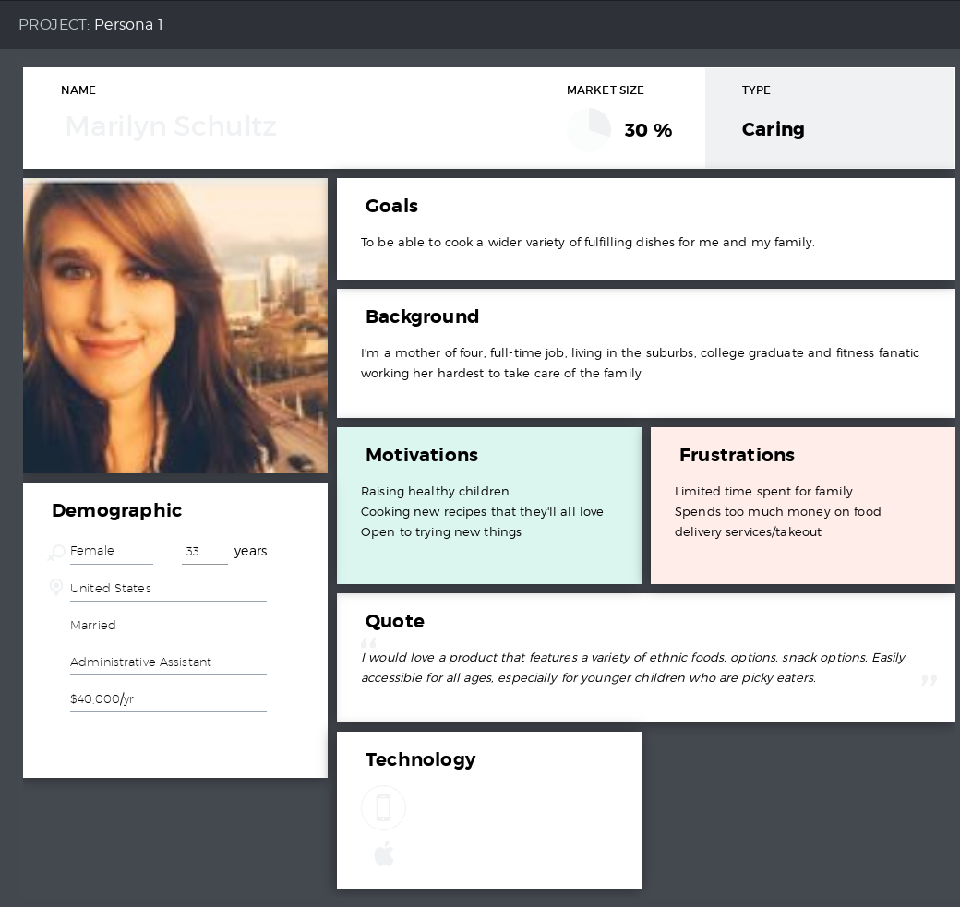

Educators:

### 

System Administrator:

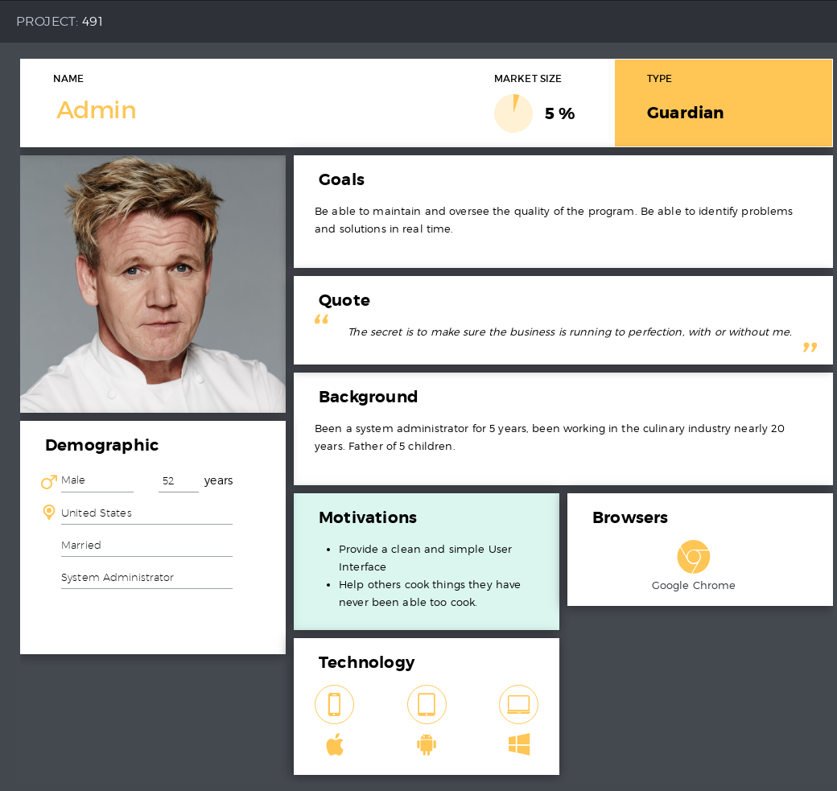

guestUser:

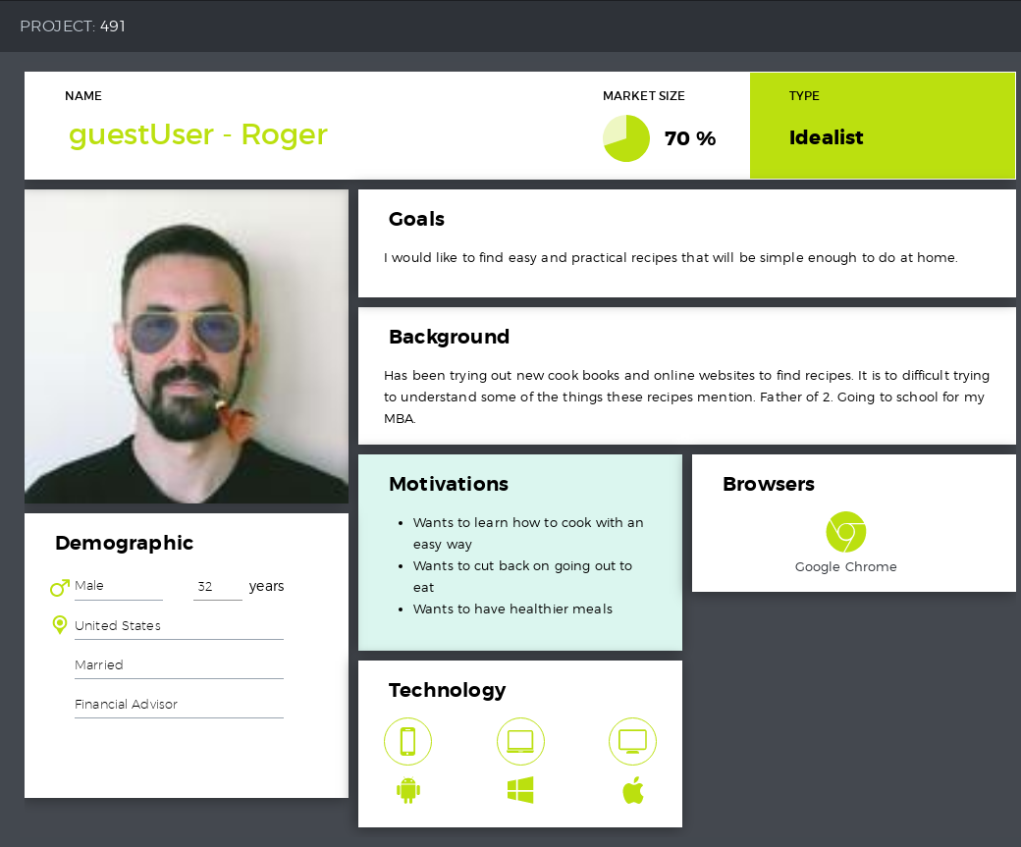

userAccount:

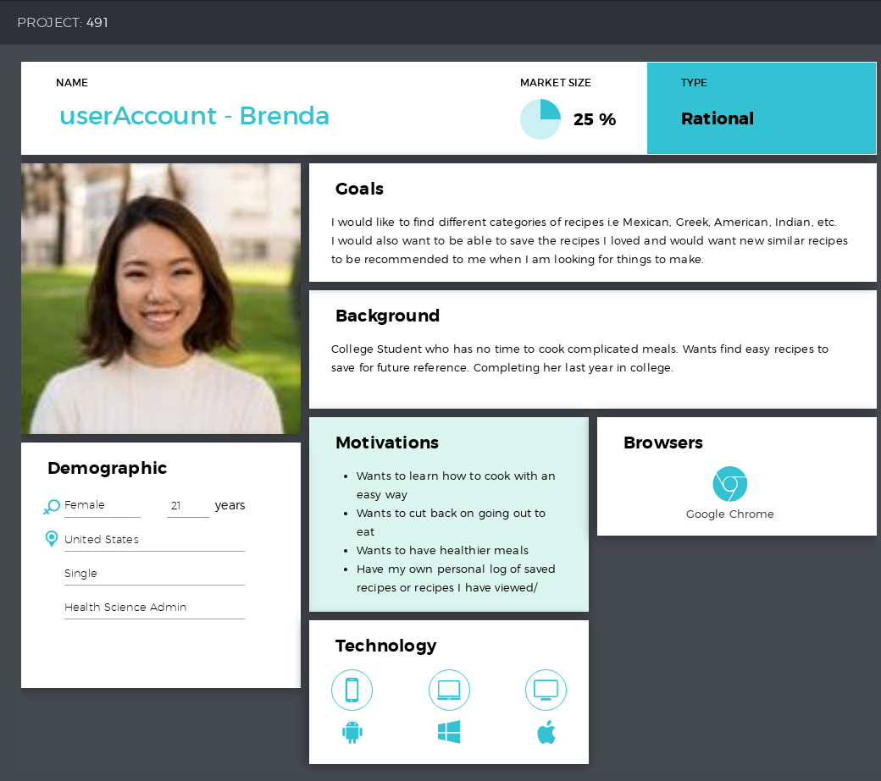

# User Stories

System Admin

1. As a system admin, I want to be able to add a Guest User so that they can become an Account User.
2. As a system admin, I want to be able to delete an Account User so that Account cannot be used.
3. As a system admin, I want to be able to update the details of my application so that the application will keep updated details always.

Guest User

1. As a guest user, I want to be able to search for recipes so that I can use the feature of the system to search for the recipe and preparation that I need.
2. As a guest user, I want to be able to register for an account so that I can become an Account User and use the Account User’s features.
3. As a guest user, I want to be able to sort the recipes I have searched so that I can view them by multiple categories in order to search for specific ones.

Account User

1. As an account user, I want to be able to search for recipes so that I can use the feature of the system to search for the recipe and preparation that I need.
2. As an account user, I want to be able to login to the system so that I can use the features of the system to accomplish what I need.
3. As an account user, I want to be able to reset my password so that I can create a new password to login to the system.
4. As an account user, I want to view my list of recipes so that I can check on the details of my list of recipes.
5. As an account user, I want to be able to add recipes to my list so that I can save the recipe into a list of other recipes for future use.
6. As an account user, I want to be able to delete recipes off my list so that I can get rid of recipes that do not interest me any longer.
7. As an account user, I want to be able to sort the recipes I have searched so that I can view them by multiple categories in order to search for specific ones.

# Server Site Map

# 

# Page Description

|  |  |
| --- | --- |
| **Page** | **Elements** |
|  |  |
|  |  |
|  |  |
|  |  |

# 

# Wireframe

# 

# Interfaces

# 

# Additional Functional Requirements

# 

# Non-functional Requirements

# 

# Performance Requirements

# 

# Future Iterations